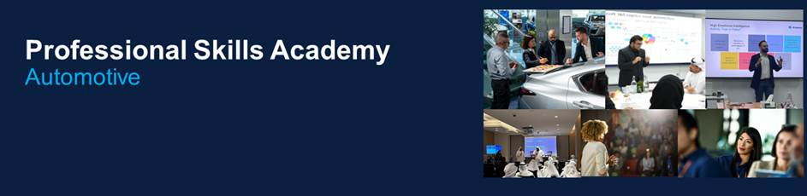
Dear Colleagues,
We’re excited to share the October line-up of Professional Skills Academy sessions. Next month is packed with opportunities to sharpen your skills and get ahead, but spots are limited!
The Professional Skills Academy gives you access to courses designed to build skills for today’s needs and tomorrow’s opportunities.

Alongside these live sessions, you’ll also find LinkedIn Learning recommendations aligned to our organisations six strategic priorities with our skills library, giving you more ways to grow, anytime, anywhere.

📌 Why sign up?
- Learn from expert facilitators
- Build career-boosting skills linked directly to your Individual Development Plan (IDP)
- Join peers across Automotive in exclusive sessions (first come, first served!)
👉 Book Now using the registration links below to secure your place. Spots are limited and available on a first-come, first-served basis. Don’t miss out!

👉 Watch  this quick video, learn how to use our course registration platform. 

October Monthly Offerings

Developing Effective Interpersonal & Communication Skills
03, 13 & 22 October | 1-day training
Public Speaking
03 October | 1-day training
Emotional Intelligence
06 October | 1-day training
Conflict Resolution
06, 21 & 24 October | 1-day training
Excel Mastery Training
09 & 10, 15 & 16 October | 2-day training
Finance for non-finance
09 & 10 October | 2-day training
Critical Thinking
09 October | 1-day training
Future and Foresight Skills
10 October | 1-day training
Creativity & Innovation for Problem Solving
23 October | 1-day training
Powerful Feedback
7, 25 October | 60-minute virtual training session
10 Minute Coaching
17, 29 October | 60-minute virtual training session
Growing Your People
18, 28 October | 60-minute virtual training session

LinkedIn Recommendations (with certificates)

 | The Service Mindset: Enhancing Your Customer-Centric Skills  Customer-Centric Approach | 
 | Succeeding with an Ownership and Accountability Mindset  Fostering a Culture of Ownership & Growth | 
Strategic Partnerships
Strengthening Partnerships

Let’s make October your month of growth. 🚀
Regards,
Al-Futtaim Automotive Talent Centre

Confidential - Internal Al-Futtaim



Dear Associate,
Group Sustainability Office and Automotive Sustainability Lead are thrilled to invite you to the upcoming monthly Sustainability townhall, "Carbon Academy Townhall" taking place today, October 14th – From 10:00 to 11:00 AM. This event is an excellent opportunity for us to come together, share our progress, and learn from top-tier experts in the field of sustainability.

Click Here to Join

Here is the agenda for the townhall:

- Carbon Data Management Project Updates (15 min): Presented by Cong Luo, Group GM in Sustainability
- Best Practices in Sustainability Data Infrastructure & Operating Models (15–20 min): Led by Terra.do by Anshuman, featuring Dubai-based speaker Arooshi Dahiya
- Success Stories in Sustainability Data Management (15–20 min): Led by Watershed, with Rich Moore to share how global organizations successfully managed their sustainability data
- Q&A and Reflection (10 min): Open floor for questions, feedback, and peer sharing

This townhall is a pivotal moment for us to witness the progress of our carbon data management project, gain knowledge from global experts, and offer our feedback on our evolving data infrastructure.

We look forward to your participation. Let's make this townhall a success by coming together and engaging in meaningful discussions.

Regards,



Dear Associates,

Congratulations! You are confirmed to attend the Finance for Non-Finance as part of your professional development journey on PeopleHub.

Here are the details you need to know:
📅 Date: 23rd and 24th Sept 25
🕘 Time: 9:00 AM to 04:00 PM
📍 Location: Al-Futtaim Automotive Talent Centre

What’s expected from you:
- ⏰ Be on time. Please arrive promptly. Late arrivals or no-shows will incur an AED 500 charge.
- 💻 Bring your laptop and devices. These will be needed for practical exercises.
- 🥗 Lunch is included. Refreshments will also be provided.
- 📚 Engage fully. This training is designed to help you master your finance skills—your active participation will make the difference.

We’re excited to have you on board and look forward to supporting your growth!

If you have any questions, please reach out to the aatc@alfuttaim.com .

Best regards,
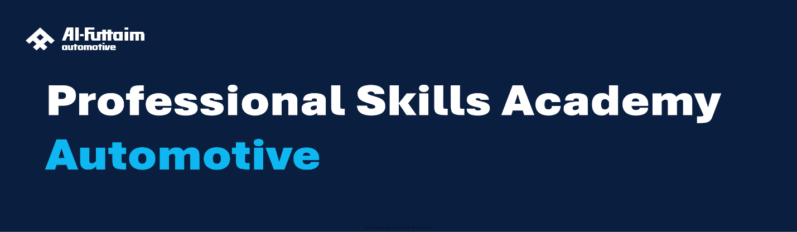
Dear Colleagues,

We’re excited to launch the Professional Skills Academy at Al-Futtaim Automotive, a new approach designed to support your learning and development, aligned with your career goals. This launch reflects the Right Skillset pillar of our people strategy and brings to life our Vice Chairman’s vision of building a culture of growth and ownership.

What is the academy?
- Offer a wide variety of expert-led learning opportunities
- Helps associates take control of their career by guiding them on how to build an effective development plan
- Recognises effort and initiative through monthly Learning Champions
- Build a learning culture where curiosity and progress are celebrated
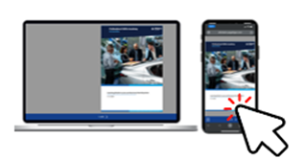
Explore the Learning Guide: click here

Ready to drive your capabilities forward?
Join a Learning Roadshow to get hands-on support.

Whether you need help navigating the Professional Skills Academy, choosing the right course, updating your Individual Development Plan, or using our learning tools, our team is here to guide you, digitally or in person.

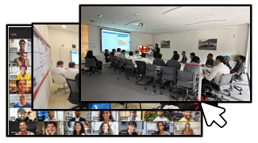

Choose your preferred date, location by clicking here.
Drive Your Growth. Shape Our Future.

Best Regards,
Automotive Talent Centre Team

Internal Use: Al-Futtaim Group

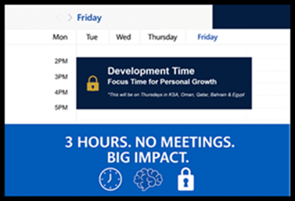
Dear Fatma Abdulhakim Omar Al Sagaf,
Every Friday from 2–5 PM is your dedicated Development Time, a quiet space to learn, reflect, and grow without distractions.
Make the Most of Your Week, here's How:
🔹 Join Today’s Live Session (3–4 PM):
Discover practical steps for delivering Powerful Feedback – Join here:
🔹 Level Up with LinkedIn Learning:
Explore our top picks to boost your skills:
- The Service Mindset: Enhancing Your Customer-Centric Skills
- Succeeding with an Ownership and Accountability Mindset
- Strategic Partnerships
🔹 Celebrate Our Learning Champions:
Meet the newly announced champions driving growth and inspiration.
For questions, reach out to us at AATC@alfuttaim.com.
Your growth powers ours. Let’s keep building together.
Kind Regards,



Dear Associates,

Congratulations on completing a major milestone in your learning journey! 🌟

You’ve successfully completed your course—now it’s time to take the next step and apply what you’ve learned to your daily work. To make your growth visible and measurable, please follow the steps below in PeopleHub to add your post-learning actions and request feedback on your new skills.

1️⃣ Go to Development Goals  - Navigate to PeopleHub → Goal Settings → Development Goals.  - (Refer to the screenshot below — see the arrow pointing to “Development Goals.”) | 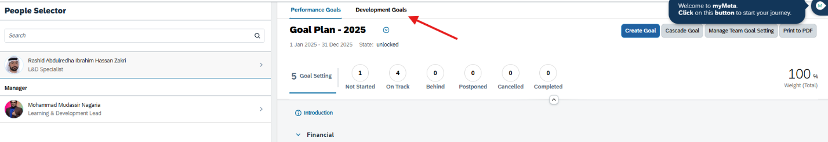
2️⃣ Create an Activity under Your IDP  - On your created IDP goal, click the three dots (⋯) in the top-right corner.  - Select “Create Activity.”  - (See the arrow in the image below showing where to click “Create Activity.”) | 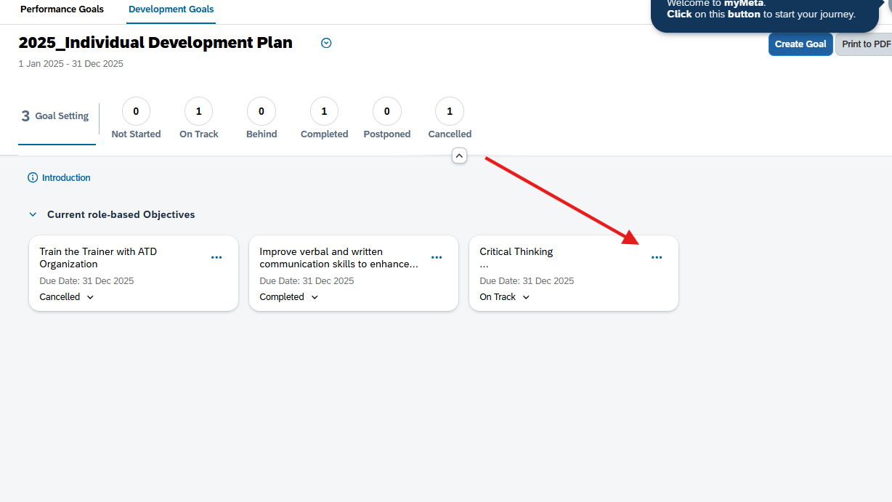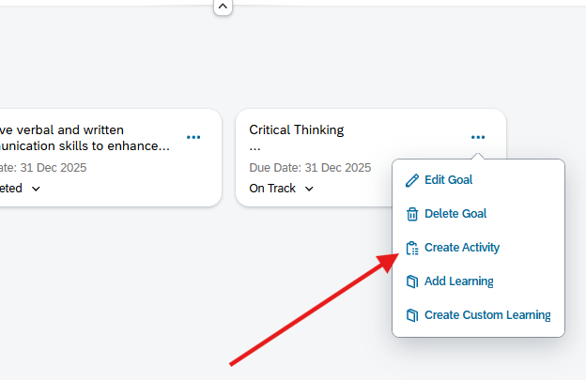
3️⃣ View Your Created Activity  - Once created, click on your new activity to open it.  - (Refer to the image where the arrow points to your created activity, e.g., “Leverage critical thinking in X project.”) | 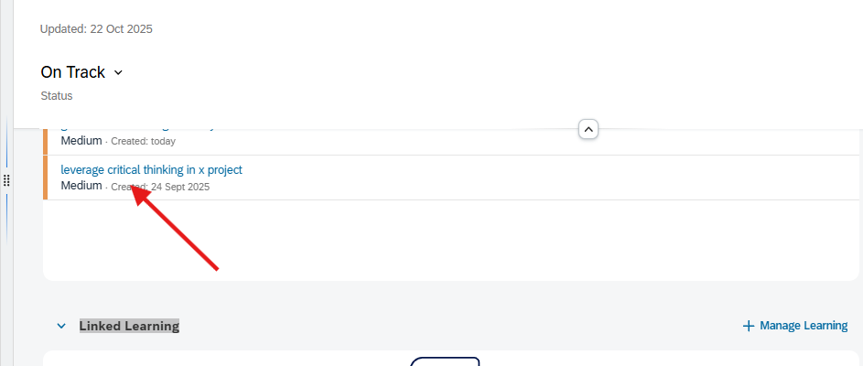
4️⃣ Request Feedback  - Inside your activity, click “Request Feedback” on the top-right corner.  - Select your Line Manager or Peers to provide feedback on how you’ve applied the skills gained from the course.  - (Refer to the image with the arrow showing “Request Feedback.”) | 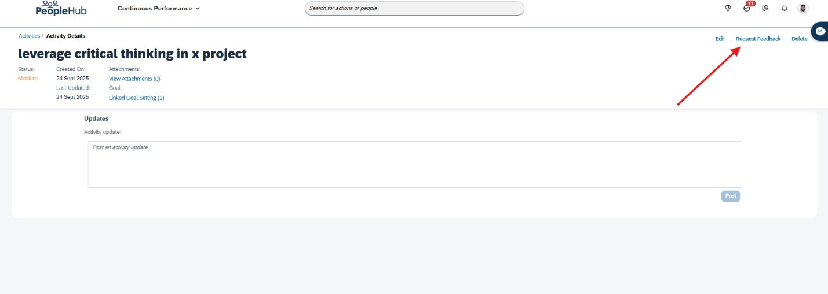

💡 Why This Step Matters

Completing the course was an important milestone—now it’s time to show impact. Adding these activities and requesting feedback helps you demonstrate real-world application of your learning and ensures it’s recognized as skills gained under your Individual Development Plan (IDP).

Let’s keep the momentum going—learn, apply, and grow!

Best Regards,
Automotive Talent Centre Team

Dear Colleagues,
We’re excited to share the Novmber line-up of Professional Skills Academy sessions. Packed with opportunities to sharpen your skills and get ahead, but spots are limited!

The Professional Skills Academy gives you access to courses designed to build skills for today’s needs and tomorrow’s opportunities.

Alongside these live sessions, you’ll also find LinkedIn Learning recommendations aligned to our organisations six strategic priorities with our skills library, giving you more ways to grow, anytime, anywhere.

📌 Why sign up?
- Learn from expert facilitators
- Build career-boosting skills linked directly to your Individual Development Plan (IDP)
- Join peers across Automotive in exclusive sessions (first come, first served!)
👉 Book Now using the registration links below to secure your place. Spots are limited and available on a first-come, first-served basis. Don’t miss out!

👉 Watch this quick video, learn how to use our course registration platform.

November Monthly Offerings

Developing Effective Interpersonal & Communication Skills
05, 10, 19, 21 November | 1-day training
Design Thinking
12 Nov | 1-day training
Emotional Intelligence
10 November | 1-day training
Conflict Resolution
4, 6, 11 November | 1-day training
Excel Mastery Training
17 & 18, 19 & 20, 27 & 28 November | 2-day training
Business Simulation - Finance for non-finance
7, 10, 11, 24, 25 November | 1-day training
Impactful Presentation
26 & 27 November | 2-day training
Future and Foresight Skills
17 November | 1-day training
Creativity & Innovation for Problem Solving
3 November | 1-day training
Powerful Feedback
11 November (11am) | 60-minute virtual training session
10 Minute Coaching
20 November (11am) | 60-minute virtual training session
Growing Your People
21 November (4pm) | 60-minute virtual training session

LinkedIn Recommendations (with certificates)

The Service Mindset: Enhancing Your Customer-Centric Skills
Customer-Centric Approach
Succeeding with an Ownership and Accountability Mindset
Fostering a Culture of Ownership & Growth
Strategic Partnerships
Strengthening Partnerships

Let’s make November your month of growth. 🚀
Regards,
Al-Futtaim Automotive Talent Centre

